Nexus certificate of completion
Aerial Lift Operator Certificate
This Certificate Acknowledges
Dwight Lee
EQUIPMENT COVERED:
ROUGH TERRAIN Aerial Lift [CLASS VID, Boom / Aerial Lift]

has successfully completed site-specific training, including safe operation in construction environments with variable contain

Training Completed: 01/06/2026-Valid until 01/06/2028
Duration: Hours [1 Hours Theory/1 Hours Practical]
Certificate ID: NFS- 2026.01.06-LeeD

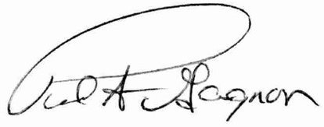

Certifying Officer
Paul Gagnon - Owner

